SOG Web Store PDF Facts:

PDF Instructions: You will be allowed to download and save/view a PDF 4 separate times; after the 4th time the PDF will no longer be available in your personal Downloads folder in the School of Government Web Store. Please SAVE your PDF to your local/personal hard drive or a disk for continuous viewing.
PDF Immediate Availability: After submitting your order, a "Thank you for your Order" screen appears. This page will display your order confirmation number and right below that number will be a link to your PDF for immediate download.
PDF Accessibility: To retrieve your PDF, logon to the SOG Web Store, click on the "My Account" tab in the upper right-hand corner and select "My Downloads" under Orders. A My Download's Form will appear with your PDF. Information will also be provided regarding the remaining number of Downloads allowed.

The following series of steps is a more detailed explanation for downloading PDFs:

- Click on “Log In” to log into the SOG Webstore.

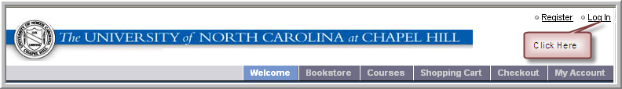

- Sign in: Enter your SOG Web Store Login and Password and Click on the “Continue” Button

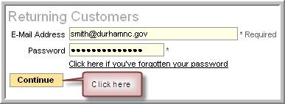

- Click on “My Account” Tab

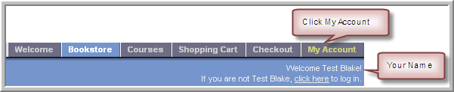

- Click on “My Downloads”

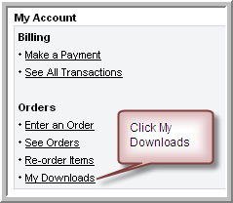

- Saving your PDF

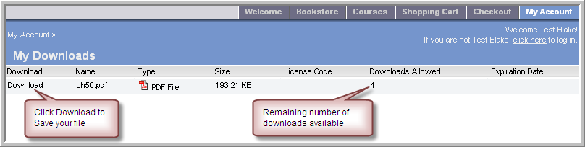

- PDF Bookmarks

Your PDF file should display the bookmarks panel. This is one of the navigational tools normally displayed on the left of the Adobe Acrobat Reader screen. If bookmarks are not displayed, click on the bookmark icon or choose View–Navigational Panels–Bookmarks.

